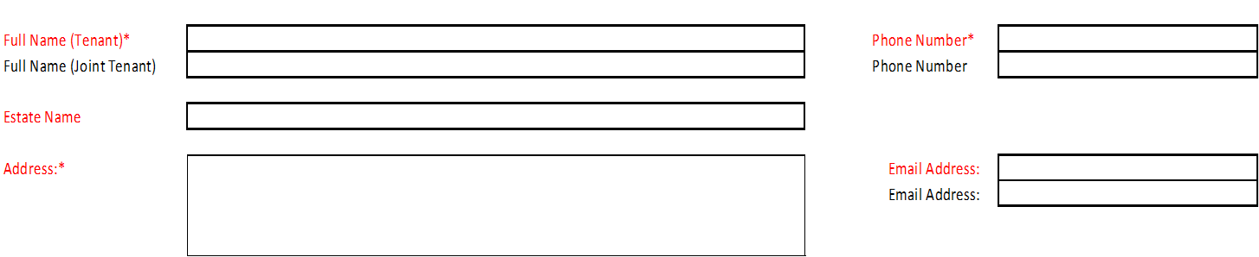

Please indicate your preferred method of contact and how you would like to receive correspondence from us

SMS (Text) Email  Post 

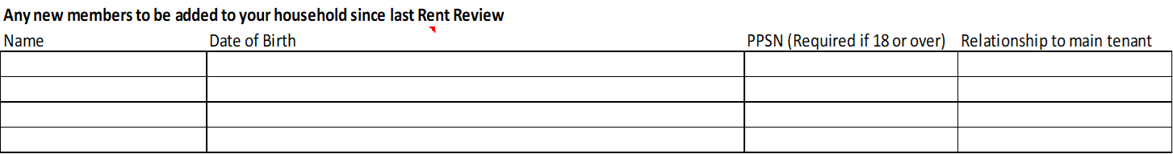

**Any members to be removed from your household since last Rent Review**

|  |  |  |  |
| --- | --- | --- | --- |
| Name | Date of Birth | PPSN | Relationship to main tenant |
|  |  |  |  |
|  |  |  |  |
|  |  |  |  |

**INCOME DETAILS**

**Please supply all supporting income documentation and details for every household member in receipt of an income and is over 18 and not in full time education.**

**Please tick the payment types applicable to your household along with the amounts.**

**For members of your household over 18 and under 23 in Full Time education please supply letter from College/School as evidence.**

Are you Employed YES/NO Are you Self Employed Yes/No

|  |  |  |  |
| --- | --- | --- | --- |
| **Social Welfare Type** | **Social Welfare Weekly Amount** | **Social Welfare Type** | **Social Welfare Weekly Amount** |
| Jobseekers Allowance  |  | Blind Pension  |  |
| Job Seekers Benefit  |  | Domiciliary Care  |  |
| One Parent Family  |  | Supplementary Welfare  |  |
| Old Age Pension  |  | Working Family Payment  |  |
| Disability Allowance  |  | Maintenance Payment |  |
| Disability Benefit  |  | Back to Work  |  |
| Carers Allowance  |  |  |  |
| Half Carers Allowance  |  |  |  |
| Illness Benefit  |  |  |  |
| Fuel Allowance  |  |  |  |
| Living Alone Allowance  |  |  |  |
| Back To Education  |  |  |  |